HOLY TRINITY LUTHERAN CHURCH
1101 W. Hudson Road P.O. Box 219
Phone: (479) 636-1135 Rogers, Arkansas 72757
FAX: (479) 636-1188 E-Mail: office@holytrin.org
Web: www.holytrin.org
Pastor: Rev. Eric Longman (elongman@holytrin.org)
Visitation Pastor: Rev. H.L. Bernthal (thebernthals@yahoo.com)
Education/Youth: Mr. Cameron Pullmann (cameron@holytrin.org)
Director of Music: Mrs. LeAnn Girshner (maestro_LMM@yahoo.com)
Office Manager: Ms. Elaine Taylor (elaine@holytrin.org)
Office Assistant: Ms. Krista Malone (krista@holytrin.org)

Welcome
If you’re new here, WELCOME! Thank you for coming. We pray that our time together in the Word would build up and strengthen your faith in Jesus Christ. Please fill out the Connection Card in your bulletin and come again. As a reminder, be sure to turn off or silence your cell phone during the service.

If you don’t have a church home in Northwest Arkansas, we invite you to consider making Holy Trinity your church home. Speak with Pastor Longman or one of our elders for more information.
Divine Service, Setting One • August 4, 2019
As you enter the Sanctuary, please respect others
who may be quietly preparing for worship.

Prayer Before Worship
Gracious Lord God, I thank and praise You for the many gifts you so graciously grant, especially the gift of salvation through Your Son, Jesus Christ. So often, I get fixated on the things of this world, caught up in a never-ending quest for earthly wealth or possessions. I forget that my identity and value are in You! Help me to re-focus and open my mind to hear and be shaped by your Word today. In Jesus’ Name, Amen.

Welcome

SERVICE OF THE WORD

Stand
Hymn of Invocation LSB 730
“What is the World to Me?”

Confession and Absolution LSB 151
L In the name of the Father and of the T Son and of the Holy Spirit.
C Amen.
L If we say we have no sin, we deceive ourselves, and the truth is not in us.
C But if we confess our sins, God, who is faithful and just, will forgive our sins and cleanse us from all unrighteousness.

Silence for reflection on God’s Word and self-examination.

L Let us then confess our sins to God our Father.
C Most merciful God, we confess that we are by nature sinful and unclean. We have sinned against You in thought, word, and deed, by what we have done and by what we have left undone. We have not loved You with our whole heart; we have not loved our neighbors as ourselves. We justly deserve Your present and eternal punishment. For the sake of Your Son, Jesus Christ, have mercy on us. Forgive us, renew us, and lead us, so that we may delight in Your will and walk in Your ways to the glory of Your holy name. Amen.

L Almighty God in His mercy has given His Son to die for you and for His sake forgives you all your sins. As a called and ordained servant of Christ, and by His authority, I therefore forgive you all your sins in the name of the Father and of the T Son and of the Holy Spirit.
C Amen.

Kyrie LSB 152

Hymn of Praise “This is the Feast” LSB 155

Salutation and Collect of the Day LSB 156

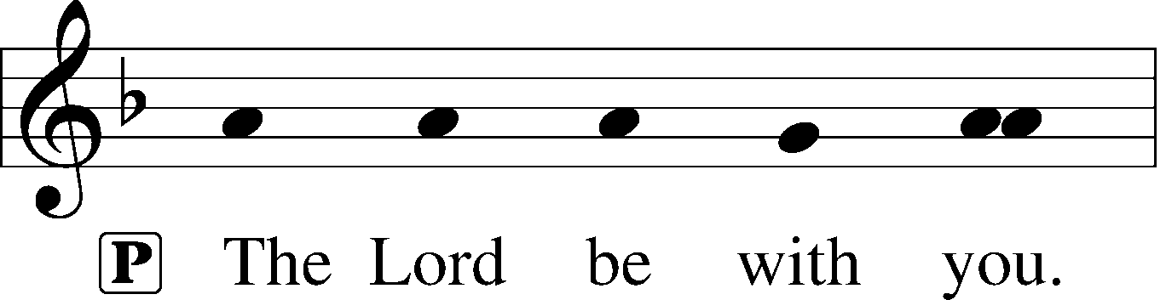
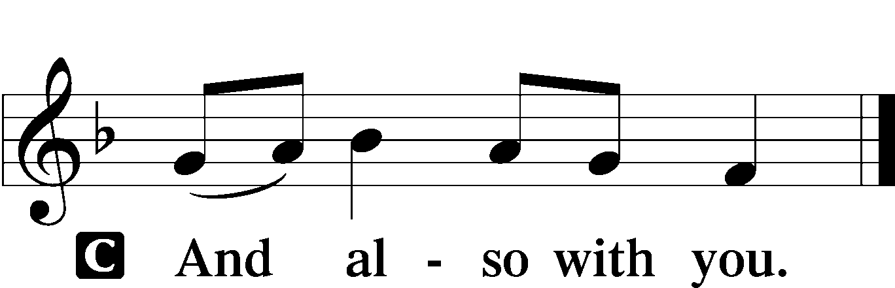

L Let us pray. O Lord, grant us wisdom to recognize the treasures You have stored up for us in heaven, that we may never despair but always rejoice and be thankful for the riches of Your grace; through Jesus Christ, our Lord, who lives and reigns with You and the Holy Spirit, one God, now and forever.

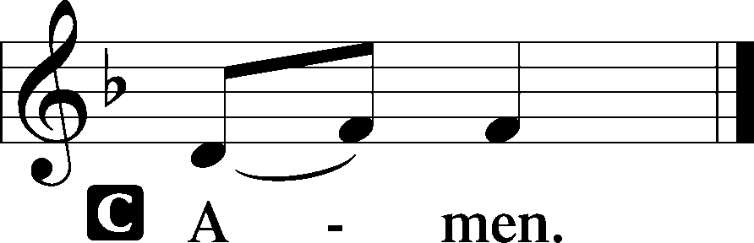
Sit
Old Testament Reading Ecclesiastes 1:2, 12-14, 2:18-26
Epistle Reading Colossians 3:1-11

After the readings:
L This is the Word of the Lord.
C Thanks be to God.

Stand
Alleluia and Verse LSB 156

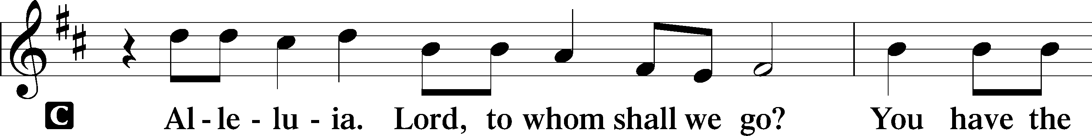
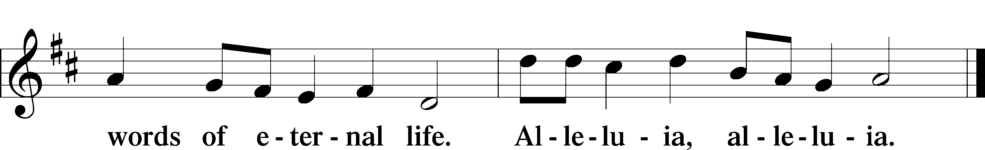

Holy Gospel Luke 12:13-21

L The Holy Gospel according to St. Luke, the twelfth
chapter.
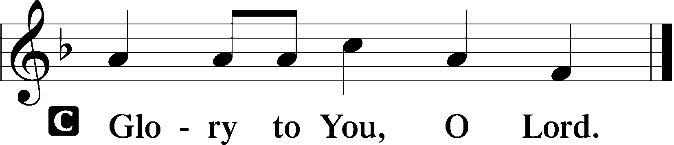

After the reading:
L This is the Gospel of the Lord.
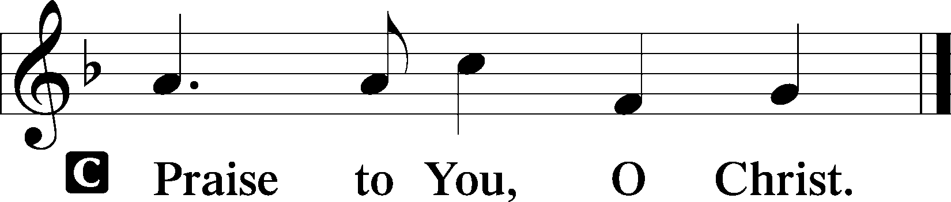

Hymn of the Day LSB 707
“Oh, That the Lord Would Guide my Ways”

Sit
Sermon Rev. Eric Longman

Stand
Nicene Creed LSB 158

Prayer of the Church LSB 159
Sit
Offering
8:00am “Build My Life” Barrett, Asbury
Soloist: LeAnn Girshner
10:45am “My Jesus, I Love Thee” arr. Pethel
French Horn: Louis Plaisance

Stand
Offertory “What Shall I Render…” LSB 159

SERVICE OF THE SACRAMENT
In the Lutheran Church - Missouri Synod we believe that as we receive the bread and wine of the Lord's Supper we also receive the true Body and Blood of Jesus Christ. We also believe that the Lord’s Supper is a celebration of the oneness in faith, life, and worship we have as a congregation. Reception of the Sacrament by Christians not fully united with us in doctrine implies a oneness that does not exist and for which we must all pray. Lutherans who have been instructed in the meaning of the Lord's Supper are invited to commune with us. First time visitors are asked to speak with the pastor before communing.

Preface LSB 160

Sanctus LSB 161

Prayer of Thanksgiving LSB 161

Lord’s Prayer LSB 162

The Words of Our Lord LSB 162

Pax Domini LSB 163

Agnus Dei LSB 163
Distribution Hymns

- “I Come, O Savior, to Thy Table” LSB 618
- “God of Grace and God of Glory” LSB 850
- “Praise the Almighty, my Soul, Adore Him” LSB 797

Post-Communion Canticle “Thank the Lord” LSB 164

Post-Communion Collect LSB 166

Benediction LSB 166
P The Lord bless you and keep you. The Lord make His face shine on you and be gracious to You. The Lord look upon You with His favor and T give you peace.
C Amen.

Sending Hymn LSB 789
“Praise and Thanksgiving, Father, We Offer”
SERVING IN GOD’S HOUSE TODAY
Greeters: 8:00 – Elaine Launderville
& Vernon Schmiegelow
10:45 – Margot Legge & Sharon Davis
Readers: 8:00 – Leyland Hermes
10:45 – Eric Kerr
Video: 8:00 – John Jenkins
10:45 – David Lehenbauer
Acolyte: 8:00 – Jena Eisma
10:45 – Landen Kerr
Lead Counters: David & Connie Heinz
Counters: Omar & Ione Kauffeld
Lawn Care: Team #3 (Gas)
Altar Guild: Bettye Platt & Laurie Martin
Elders: 8:00 – Dave Ferguson
10:45 – Brent Garner
Ushers: 8:00 – Team E: Dave Frevert, Dean Eisma, Clayton Studyvin, Ken Rader, Tommy Byrd
10:45 – Team F: Dave Lehenbauer, Matt Bolte, Leroy Meyer, Evan Wright, Liam Scott, Duane Wright
Office Helpers: Karen Launderville (Fri., 8/2 at 1:00 pm)

ALTAR FLOWERS The Altar Flowers are given to the Glory of God by Sabrina Isbell thanking God for giving his only Son to die for us.

NEWS AND NOTES Remember to pick up this week’s news and notes from the Narthex. Ushers have extra copies available. You can receive your personal copy via e-mail by sending your e-mail address to office@holytrin.org

THANK YOU from Pastor and Donna Longman for the wonderful installation service and reception last week! We are so excited to be here and have been amazed by the kindness and generosity that has been shown to us. We look forward to the wonderful adventures that God has in store for us as we serve together in God’s Kingdom!

